

Pokhara University Affiliate

**LA GRANDEE INTERNATIONAL COLLEGE**

Simalchaur, Pokhara

Final Defense

on

File Sharing System

Submitted to:

La Grandee International College

Bachelor of Computer Application (BCA)

Program In partial fulfillment of the requirements for the degree of Program Name under Pokhara University

**Submitted By:**

**Name Program, Semester PU Registration No.**

Rakesh Chhetri BCA 4th Semester 2018-1-53-0123

Prakash Basnet BCA 4th Semester 2018-1-53-0121

Niraj Bohara BCA 4th Semester 2018-1-53-0118

Santosh Baniya BCA 4th Semester 2018-1-53-0127

# Acknowledgement

We would like to thank our project supervisor Mr. Sunil Pandey for the proper guidance and cooperation for the development of our project. We would like to thank La Grandee International College for providing us good guidance and constructive suggestion that help us in the successful development of our project.

With Regards,

Rakesh Chhetri (Roll No: 19530123)

Niraj Bohara (Roll No: 19530118)

Prakash Basnet (Roll No: 19530121)

Santosh Baniya (Roll No: 19530127)

# Declaration for

# “Password Cracker”

# Student’s Declaration

We hereby declare that we are the only authors of this work and that no sources other than the listed here have been used in this work.

Name of the Student: Rakesh Chhetri

Class Roll No: 23

Program, Semester: BCA,6th

Name of the Student: Prakash Basnet

Class Roll No: 21

Program, Semester: BCA, 6th

Name of the Student: Niraj Bohara

Class Roll No: 18

Program, Semester: BCA,6th

Name of the Student: Santosh Baniya

Class Roll No: 27

Program, Semester: BCA, 6t

Supervisor’s Declaration

I hereby recommend that this project entitled “File Sharing System” is done under my supervision by Rakesh Chhetri, Prakash Basnet, Niraj Bohara and Santosh Baniya during their 6th Semester in partial fulfillment of the requirements for the degree of BCA under Pokhara University is completed to my satisfaction and be processed for final evaluation.

Mr. Sunil Pandey

Date: 2022-09-16

# Letter of Approval

We certify that we have examined this report entitled “File Sharing System”, and are satisfied with the project defense. In our opinion it is satisfactory in the scope and qualify as project in partial fulfillment of the requirements for the degree of BCA under Pokhara University.

Mr. Sunil Pandey Mr.

Date: 2021-10-26

# Abstract

This project is concerned with file sharing systems. Recently, with the advancement in technology, there has been a drastic change in the way information is shared over the internet. This involves the various channels in which files can be stored and shared. Cloud sharing is a relatively new technology advancement which has been steadily taking over more and more market share in the past three years. The cloud file sharing technique makes users share files among each other with ease, easy to setup, and open-source. Cloud file sharing is publicized as the next major step for all forms of typical information technology use. From businesses, to non-profit organizations, to single users, there seems to be various applications which can use cloud file sharing or storage in daily computer usage, to offer a better, faster, and smarter way to share important document. This paper aims to build a cloud-based file sharing application, offering users the power to share files via cloud networks in the palm of their hand.

Table of Contents

List of Figures i

1. Introduction 1

2. Problem Statement 2

3. Objectives 3

4. Methodology 4

4.1 Design 5

5. Project Gantt Chart 10

6. Deliverables: 11

7. Conclusion: 12

8. References: 13

# List of Figures

Figure 1 Iterative Model 4

Figure 2 Flowchart 5

Figure 3 Context Level Diagram 6

Figure 4 DFD For Login 7

Figure 5 DFD for file upload and download 8

Figure 6 E-R Diagram 9

Figure 7 Gantt Chart 10

# 

# 1. Introduction

File sharing is the practice of distributing or providing access to digitally stored information, such as computer programs, multimedia (audio, images and video), documents, or electronic books. File sharing web application is used to upload any types of files like pdf, mp3, word, etc. into a database and can download those types of files from the database. This application is developed by using HTML, CSS, JavaScript and PHP.

Online File Sharing is a practice of sharing files among different users across the internet. Common forms of file sharing are FTP (File Transfer Protocol) model and P2P (Peer-to-Peer) file sharing network. Another common form of sharing files over the internet is for a user to upload files to a website and allow other users to download them from the website.

# 2. Problem Statement

* Users of an online file sharing website who use features like upload, download, share, search etc. would want a website that is very interactive and fast and not annoying with a lot of post backs and flashing screens.
* Another issue is the visualization of the file system where users have a limit to upload files. The normal web-based file folder view would be good, but if there are other types of visualizations it would be great. Another important issue to consider is the location where the website stores the uploaded files.

# 3. Objectives

The major goal of this project is:

* To design a web application that is necessary for organization members when they need to operate online and access files.
* To promote a user-friendly, efficient, safe way for users to upload and download files without being physically present at organization.
* To act as a backup of a important files and is secure.

# 4. Background Study

Currently the system used for storing and again retrieving the data is very costly and used at a large scale. No matters, the systems provide many operations along with data storage but they are paid system. So, because of this major disadvantage of the currently available systems, it is used by the premium users only i.e., paid users.

There are many such problems with the existing system. The main drawbacks of existing system are: - Expensive, Less-Secure & Unreliable.

# 5. Methodology

For this project we used Iterative model, as shown in the figure below:

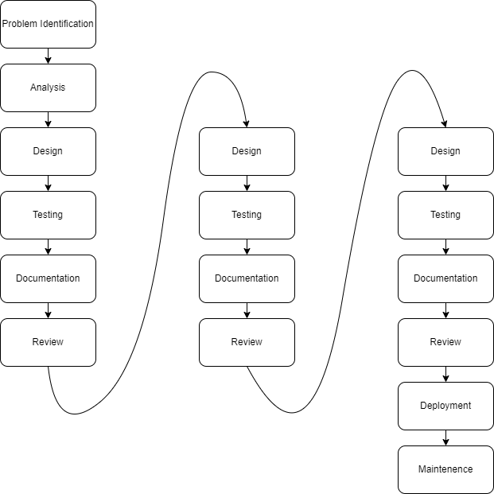

Figure 1 Iterative Model

## 5.1 Design

Flowchart

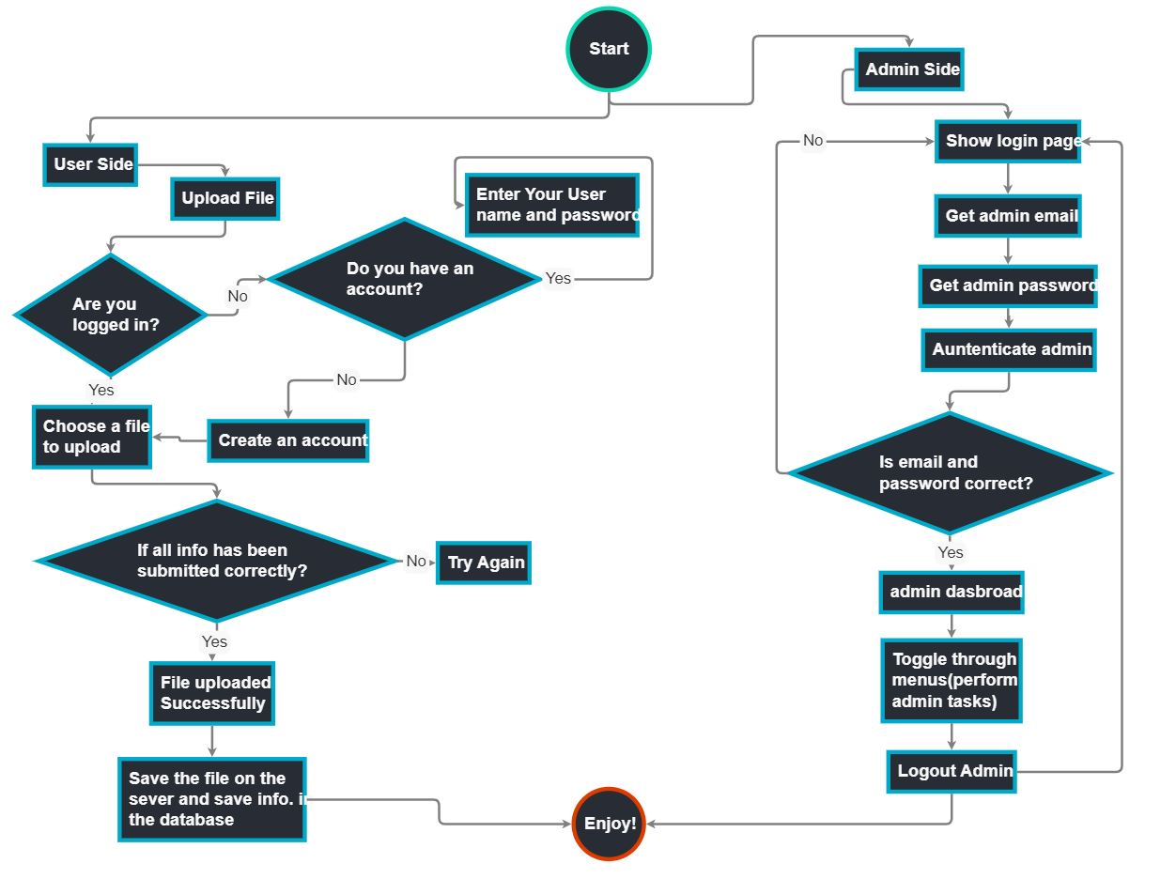

Figure 2 Flowchart

Context Level Diagram (DFD Level 0):

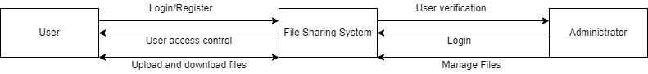

Figure 3 Context Level Diagram

Level 1 DFD for Login:

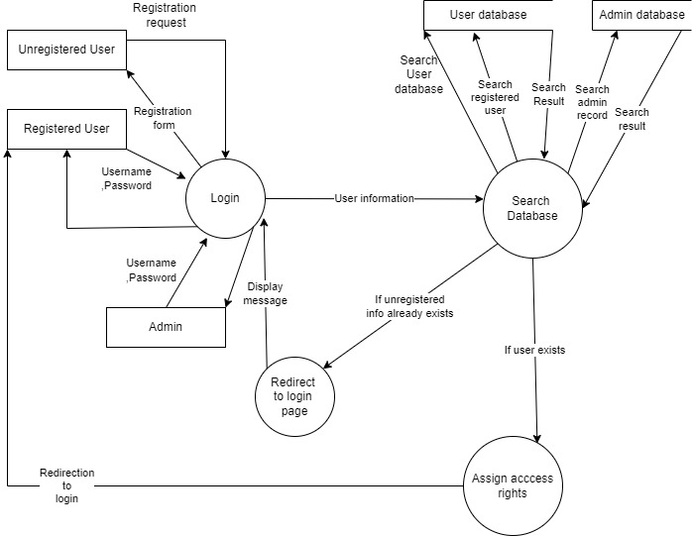

Figure 4 DFD For Login

Level 1 DFD for File Upload and Download:

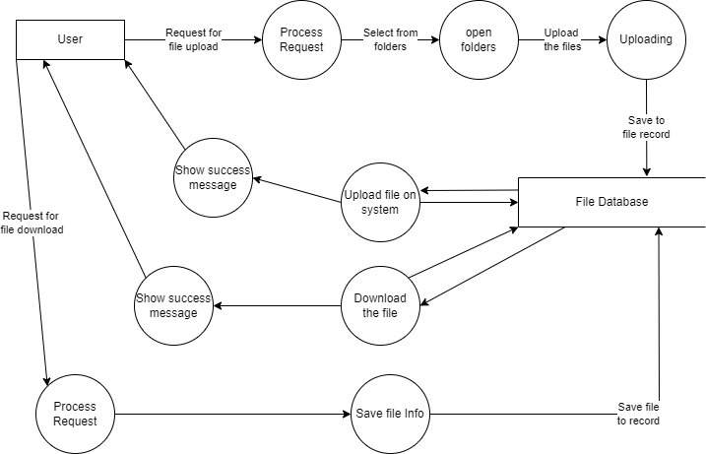

Figure 5 DFD for file upload and download

E-R Diagram:

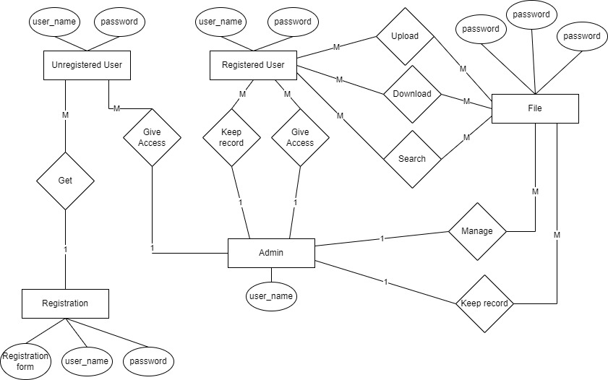

Figure 6 E-R Diagram

# 6. Project Gantt Chart

Figure 7 Gantt Chart

# 7. Deliverables:

After the successful creation of our project, it can fulfill a certain criterion for the end users. Some of the targeted pr expected outputs are:

* It would offer a secure, reliable file storage with easy to access.
* The cloud-based system can reduce the cost through sharing of peripherals and internet access.

# 8. Conclusion:

This system is a great benefit to small workstations,

where disk space is at a premium. A user can have access

to a much larger file when needed.

This system is a great benefit to small workstations,

where disk space is at a premium. A user can have access

to a much larger file when needed.

This system is a great benefit to small workstations,

where disk space is at a premium. A user can have access

to a much larger file when needed.

This system is a great benefit to small workstations, where disk space is at a premium. A user can have access to a much larger file when needed. The use of an server to centralize file entries on various clients not only simplifies various operations, it helps maintain consistency of shared data files. When changes are made to a shared file, they become available to all users immediately. This concept also allows enhancing and implementing a fault tolerance mechanism. The framework allows the system to be easily scalable hence making it available to large number of users if the file sharing requirement goes on increasing.

# 9. References:

* (2022). File Sharing. Retrieved from: https://www.techopedia.com/definition/16256/file-sharing
* (2022). Filesharing. Retrieved from: https://www.techtarget.com/searchmobilecomputing/definition/file-sharing